# **Part 1: Facebook network**

**1.4 Friend recommendation in personalized networks**

In this part, we used three different neighborhood-based measure for friend recommendation. We defined the notations as follow:

* $S_{i}$ is the neighbor set of node $i$ in the network.
* $S_{j}$ is the neighbor set of node $i$ in the network.

Three friend recommendation algorithms which we used:

* Common Neighbor Measure
$$CommonNeighbors\left(i, j\right)=\left|S_{i}∩S_{j}\right|$$

* Jaccard Measure
$$Jaccard\left(i, j\right)=\frac{|S_{i}∩S_{j}|}{|S_{i}∪S_{j}|}$$

* Adamic-Adar Measure

$$AdamicAdar\left(i, j\right)=\sum_{k∈S_{i}∩S_{j}}{\frac{1}{\log\left(\left|S_{k}\right|\right)}}$$

**Quesiton 16:**

In this question, we analyzed the personalized network of node ID 415 and created a list $N_{r}$ by picking all nodes with degree 24 in this personalized network.

$${|N}_{r}|=11$$

**Question 17:**

In this question, we applied three friend recommendation algorithms to user in list $N_{r}$. We computed the average accuracy for each user in the list $N_{r}.$ Then, we took the mean of the average accuracies of the users in the list $N_{r}.$ The mean value is the average accuracy of the friend recommendation algorithm.

|  |  |  |  |
| --- | --- | --- | --- |
|  | Common Neighbors | Jaccard | Adamic Adar |
| Average accuracy | 0.8487698 | 0.7867424 | 0.8140689 |

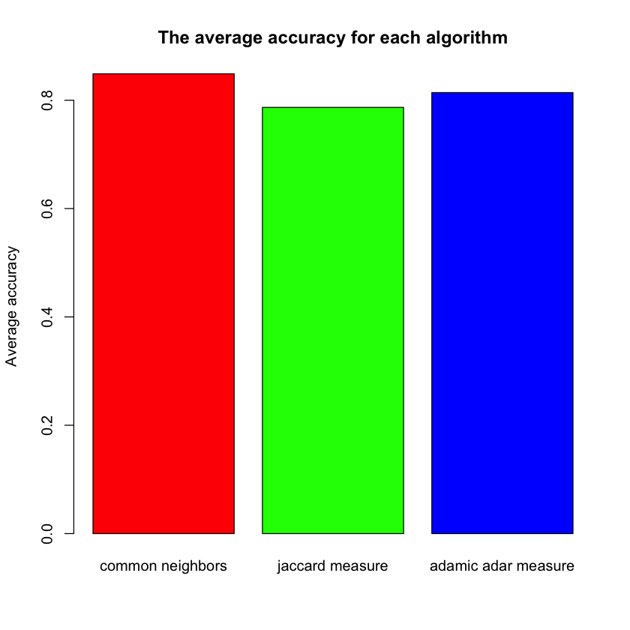

**Figure 1.4.1** The average accuracy of each algorithm